Delightful creations for your special occasions

Vegan Delights Packages

Appetizers
(Choose any three appetizers, served by the dozen)

Asian Inspired

Spring Rolls (Cabbage, scallions, carrots & beans sprouts) w/our sweet & chili sauce
- Vegetable (25 for $30)
Fried Wantons (Cabbage, carrots, scallions) w/our sweet teriyaki sauce ($35)
- Vegetable
Wings Cauliflower ($50)
- Chinese fried chicken wings (Coated in a light flour mixture) w/our “duck” sauce
- Thai fried chicken wings (Marinated in our sweet chili sauce and air fried)

Caribbean

Mini “patties” (puff pastry inside out patties)
- Vegetable (curry, jerk or cook up- sweet corn, carrots, cabbage) ($25)
Mini Skewers ($35)
- Veggie, Sweet peppers, Onion, Zucchini, carrots, cherry tomatoes, corn & Pineapple (Jerk or Island BBQ)
GT mini Cheese sandwiches (Vegan sharp cheddar cheese- GT style cheese paste, shape cut and coloring optional) ($25-$35) 15 or up to 25pp
GT Puffs ($30-$35) 15 or up to 25 pp
- Vegan Cheese or Vegetable (mashed potato, channa, sweet peppers & corn)

All American
(American, Southern, Italian & Spanish cuisines)
$25-$50 (depending on party size)

Southwestern Egg Rolls (Black beans, sweet corn kernels, Red sweet pepper) served w/ our smashed guacamole

Loaded Nacho cups- 3-layer dip (Salsa, Guacamole, Sour cream & topped w/ 3- cheese mix, black beans, sweet corn kernels & tortilla chips)
- Buffalo Wings Cauliflower- (available in mild, medium hot and spicy hot. Served w/ celery sticks, carrots & Ranch dipping sauce)
- TEXAS BBQ wings (cauliflower)
Stuffed Meatballs
- Veggie Meatballs- Mushrooms, zucchini, sweet peppers and onions- (stuffed w/ vegan mozzarella cheese, w/ marinara sauce)
Pinwheels (Thin flaky pastry filled)
- Potato & Spinach $25
- Jalapeno cheddar $25
- Sun dried tomato & pesto $35
- TEXAS BBQ “Chicken” cauliflower $40

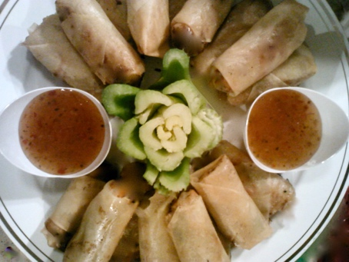
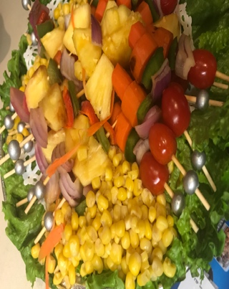

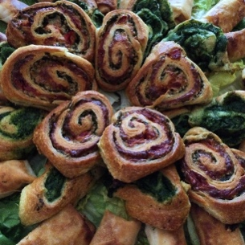

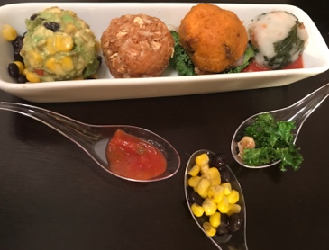
Main Menu
Vegan Bites & Vegan Delightfuls
(served in half trays and not in our typical cup containers)
Vegan Bites are our two bite, bites formed into a ball and placed on a bed based on the cuisine. (Think of this one as a Small) ANY Vegan Bite can be turned into a Vegan Delightful
Vegan Delightfuls are our Vegan Bites on a grain or carb bed. (Think of this one as a Large)

Vegan Delightfuls ($40 - $65) per half tray
Asian Zinger
Vegan bite (Broccoli, cabbage, carrots, scallion & onions) served on a short grain brown rice bed, drizzled w/our Pineapple Teriyaki sauce

Thanks-Giving
Vegan bite (Sweet potato, carrot, cinnamon & brown sugar) on a Vegan cornbread stuffing bed
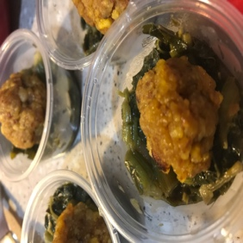

Vegan Bites
Sweet Granny's Yams
Mashed Sweet potato & Walnuts (served on a Walnut & Kale salad bed)

Sweet Plantain Mon
Mashed sweet fried plantains (served on a bed of sautéed callaloo & drizzled w/ our jerk mango passion sauce)

Buff Chick
Chicken flavored sautéed cauliflower rice (served on a celery & carrot minced bed drizzled w/ our vegan buffalo sauce)

RAW
The Sante Fe
Mashed Avocado, Sweet corn, red sweet pepper & black beans (served on a bed of romaine lettuce)
Peanutty Crunch
Honey Peanut Butter- w/ raisins and oats (served on a honey gram cracker)

The Mediterranean
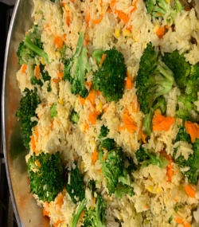
Mashed Chick peas (served on a bed of diced tomatoes & cucumbers, red onion and cilantro, drizzled w/ a vegan Tzatziki sauce)

Sides (Choose any 2 starches & 1 Vegetable)
Lo Mein (Vegetable, Chicken or shrimp)
Fried Rice
- Asian Zing (sautéed broccoli, bean sprouts, carrots in our signature lite soy sauce)
- Vegetable (sautéed onions, bean sprouts, string beans, sweet peppers)

Vegetable Stir Fry (Broccoli, bean sprouts, onions, carrots, Sweet peppers, bok choy sautéed in our lite teriyaki sauce)

Caribbean Vibes

Sides
Rice (White available)
- Jamaican Style Rice & Peas ◊ GT Style Fried Rice
- Reggae rice (a hint of curry, diced red & green sweet pepper)
Jamrock Baked Mac & Cheese (Vegan three cheese baked mac w/ sautéed island herb blend of thyme and scallion)
Roast corn
- Jerk
- Coconut roasted
- Island BBQ
GT Style Chow Mein (vegetable- onions, chana, corn, carrot, peas & sweet peppers)
Potatoes
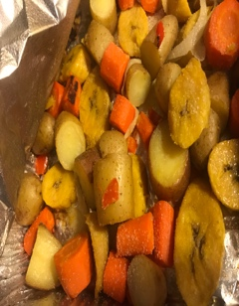
- Calypso potatoes (Yukon potatoes, sweet plantain, carrots, corn on cob pieces, red sweet peppers and yellow onions)
- Vegan- Island Mashed potatoes (w/topped with diced sweet peppers)
- GT Style Curried potatoes and Chana

All American Faves
(American, Southern, Spanish & Italian inspired Cuisines)

Entrees
Stuffed Peppers (spinach, stuffing or roasted vegetable)
Eggplant Parmesan
Cauliflower Steak (Large medium sliced w/ steak seasoning & a lite Vegan Steak sauce)

Pasta sides
Pasta (Served w/ garlic bread: cheesy or traditional)
Lasagna
- Vegetable (spinach & sweet potato OR zucchini, carrots, sweet corn kernels and onions)
- 3- Cheese (Traditional) Vegan cheeses- mozzarella & cheddar parmesan
- Vegetable (spinach & sweet potato OR zucchini, carrots, sweet corn kernels and onions)
Penne, Fettuccini or Linguine
- Garlic, EVOO & Shredded vegan Parmesan cheese
- Vegan Alfredo
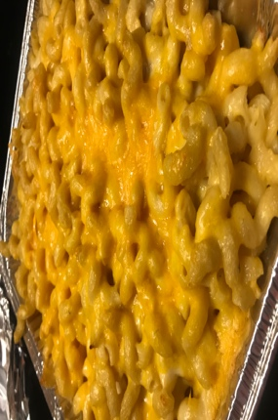
- Marinara
Baked Mac & Cheese
3- Cheese (Traditional) Vegan cheeses- mozzarella & cheddar parmesan
Seasoned (diced and sautéed red onion, red and green sweet peppers)
TEXAS Mac (Jalapeno’s & vegan cheddar)
Potatoes
- Loaded potatoes (broccoli & vegan cheddar, sweet peppers, OR seafood- oyster mushrooms)
- Mashed (traditional or potatoes bliss: red potatoes & dill)
- Roasted
◊ Baked
Rice & Grains
- Brown rice
- White Rice
- Quinoa

Salads
- Cesar (traditional style, w/ croutons, Caesar dressing & shredded parmesan cheese)
- Garden
- Spring
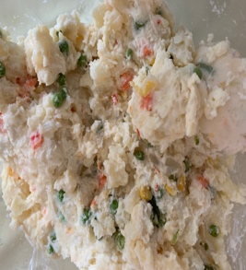
- Cowboy (black beans, sweet corn kernels, cucumber, tomatoes, red onion and red sweet pepper)
Potato Salad (vegan mayo & w/o eggs)
- Caribbean Potato salad (w/ mixed vegetables)

Pasta salad (penne or bow tie)
- Vegetable- carrot, corn, peas, sweet peppers, onions, beans & cilantro, in a lite oil based dressing
- Pesto, sundried tomato & vegan parmesan cheese
- Seafood (Oyster Mushrooms) onions, sweet peppers & a lite creamy vegan cheese sauce
Soups
Pumpkin
Tomato
Vegan Chicken flavored (Jamaican style)
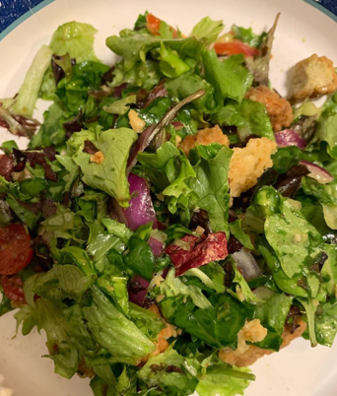
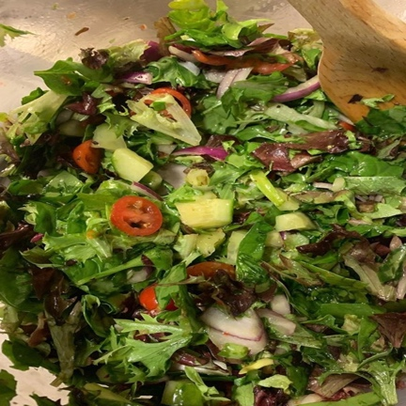

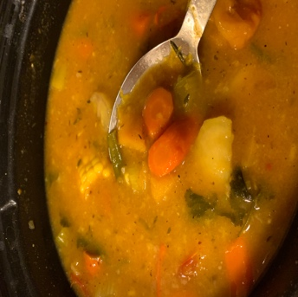

Desserts
(Choose any two)

Vegan mini cakes (Typically ordered w/o frosting or filling)
Coconut, Banana Bread, Carrot, Oreo, Strawberry, Peach Cobbler, Pineapple delight or Chocolate nut.

Frostings: Vanilla, strawberry, citrus, chocolate buttercream.

Fillings: Vanilla buttercream, Vanilla or chocolate cream cheese, Strawberry, mixed berry, pineapple, apple cinnamon, & chocolate buttercream.

Cookies & Truffle cakes

Chocolate chip
Cinnamon Sugar (brown sugar)
Banana Oat
Blueberry
Lemon
Vanilla Dream w/ sprinkles

